Feasibility Analysis

**Description about the application:**

We are in the process of making “One to Many” file sharing application. We want to make One to Many file sharing easy and secured. User uploads a file into the cloud and it generates a key. The file can be accessed only with the help of key. The file sharing is done without any authentication and disclosing the information of user. So, it’s helpful for user who don’t want to share any of his information. Uploaders and downloaders are the two types of users in this application. Same person can be both. This gives you brief idea how our application works.

**Survey:**

The following is the pie chart of the responses for the feasibility of our “one to many ” file sharing application.

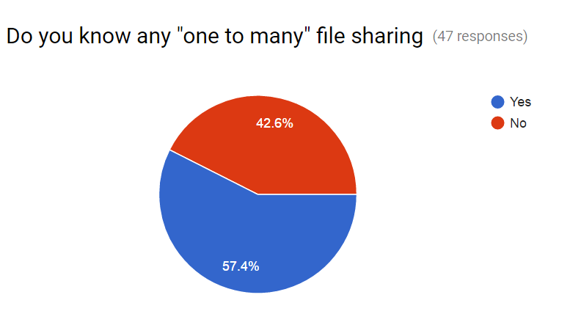

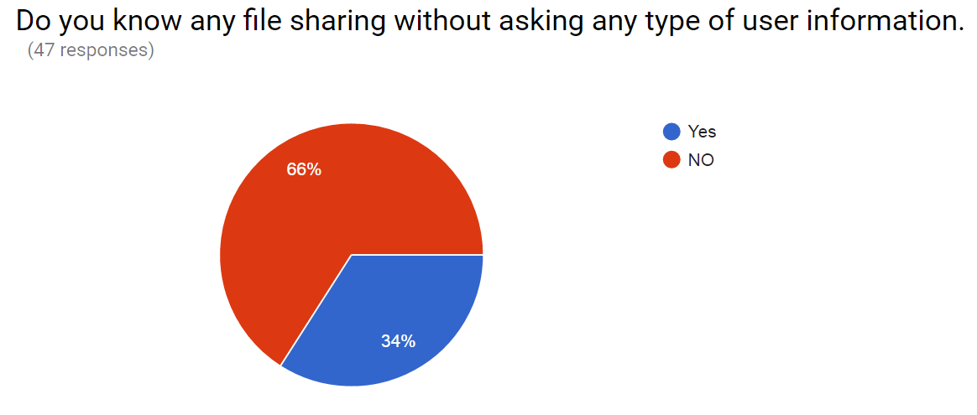

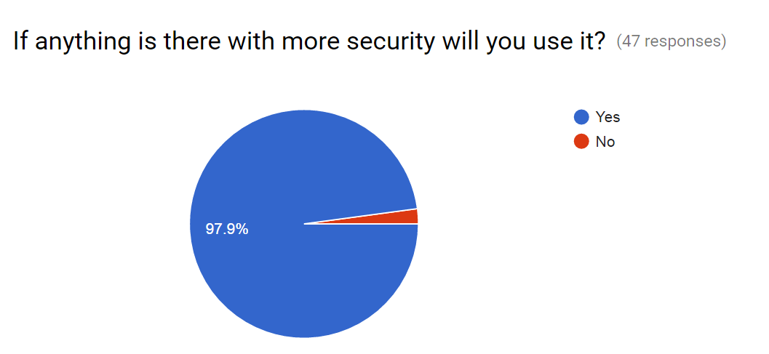

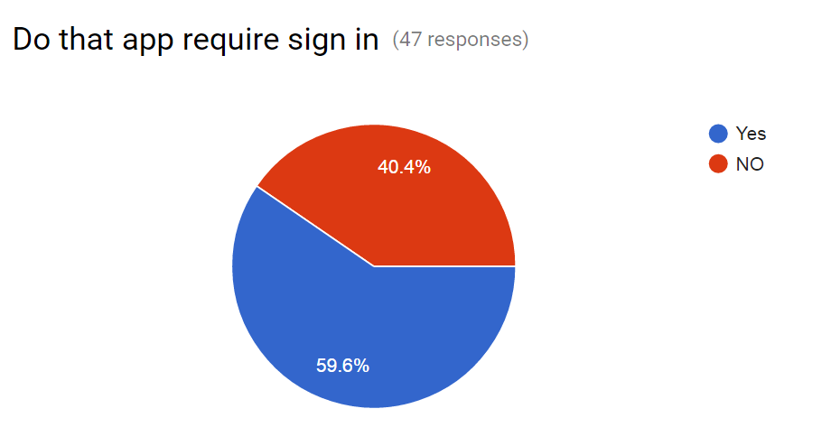

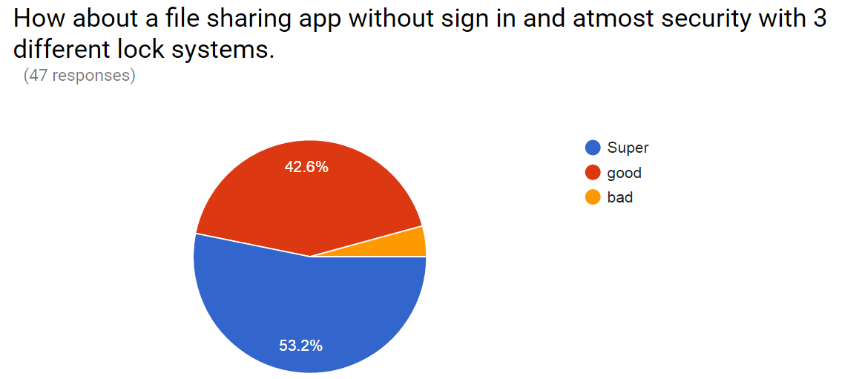

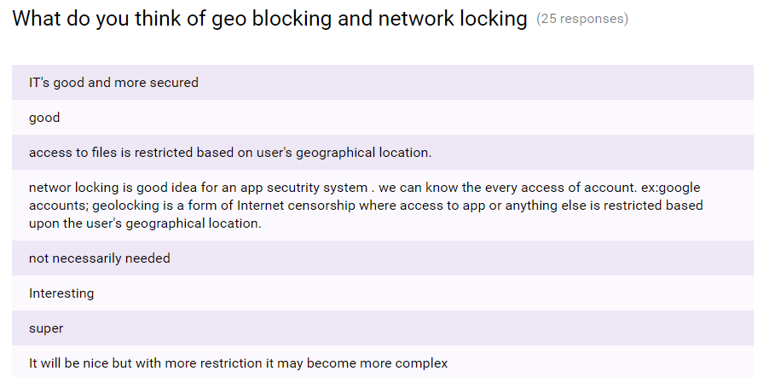

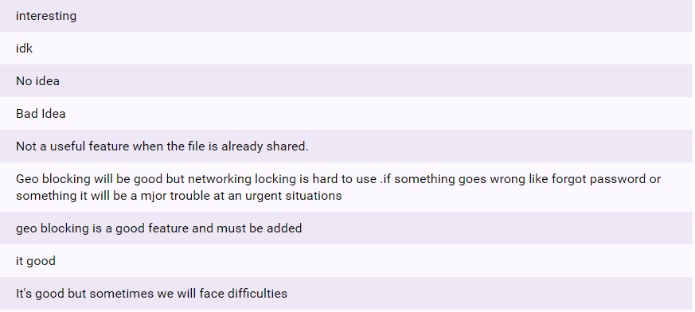

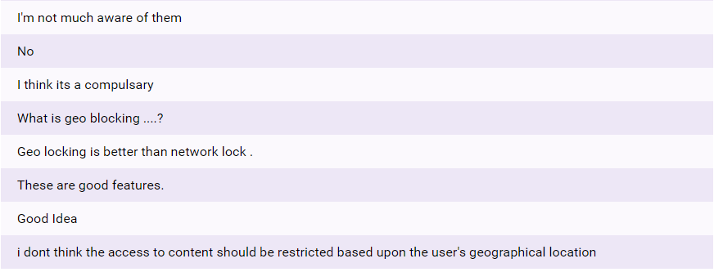

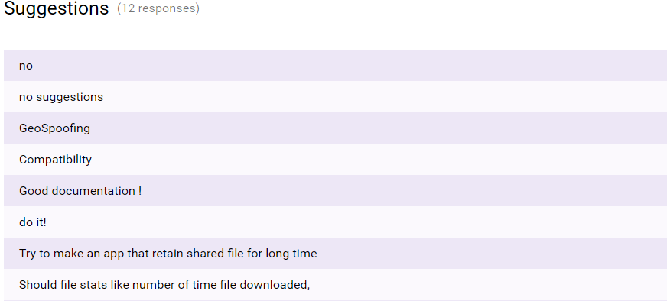

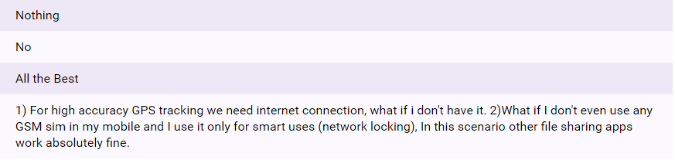

The above are the suggestions for “One to many” file sharing application. This will result in organisational development of our application.

**Some of the questions for people in Organisation which helps in the study of the system feasibility are as follows:**

**What are current process problems?**

Even though there are many file sharing but most of them are only “one to one” sharing. By chance if there is any “one to many” it requires user’s information (email id or user name etc) for accessing. So, here the problem arises when the user doesn’t want to share his personal information.

**How will the proposed system help?**

To overcome the above problem, we came up with a new idea of one to many sharing with no sign required. By this, there is no need of user/client’s information.

**Is new technology needed? What skills?**

We are using GEO-LOCK and NETWORK-LOCK to standardize the security of the file sharing through our application. GPS-LOCK uses GPS to provide location using latitude & longitude co-ordinates. NETWORK-LOCK uses SSID to share through it.

**Recommendation:**

From above all reviews it shows that the application is feasible. And also recommendable.